**A Bus Management System with Real-Time Tracking and Mobile Phone-Based Payment**

Senior Project

by

**Hussein Azzam,**

**Mahmoud Abou Khalil**

Submitted to the School of Engineering of the

Lebanese International University

Tyre, Lebanon

in partial fulfillment of the requirements for the degree of

**BACHELOR OF SCIENCE IN COMMUNICATION ENGINEERING**

**Spring 2024-2025**

**Approved by:**

**Supervisor**

Dr. Hadi Noureddine

**Committee Member**

Dr. TBA

**DEDICATION**

To someone I know and I care for

John J. Doe

To my parents, whose unwavering love and sacrifices made this journey possible. To my professors, for their guidance, and to my friends, for their constant encouragement—this achievement is yours as much as it is mine.

Hussein A. Azzam

**ACKNOWLEDGMENT**

We would like to express our deepest gratitude to our supervisor, Dr. Hadi Noureddine, for his invaluable guidance, continuous support, and insightful feedback throughout this project. His expertise and encouragement were instrumental in shaping our work.

We extend our sincere thanks to the faculty members of the School of Engineering at Lebanese International University for their knowledge and support during our academic journey.1

Special appreciation goes to our families and friends for their unwavering patience, motivation, and belief in our abilities. Their encouragement kept us moving forward even during challenging times.

Finally, we acknowledge all those who contributed directly or indirectly to the completion of this project.

Hussein Azzam

Mahmoud Abou Khalil

**ABSTRACT**

The abstract goes here with double space 12pt font. The abstract consists of one paragraph with first line indentation. The page should be numbered. The abstract goes here with double space 12pt font. The abstract consists of one paragraph with first line indentation. The page should be numbered. The abstract goes here with double space 12pt font. The abstract consists of one paragraph with first line indentation. The page should be numbered. The abstract goes here with double space 12pt font. **The abstract consists of one paragraph with first line indentation**. The page should be numbered. The abstract goes here with double space 12pt font. The abstract consists of one paragraph with first line indentation. The page should be numbered.

**TABLE OF CONTENTS**

CHAPTER 1 INTRODUCTION 1

1.1 Background 1

1.2 Problem Statement 2

1.3 General overview of the project 3

1.4 Thesis Outline 4

CHAPTER 2 Survey of Existing Methods and Similar Systems 5

2.1 Introduction 5

2.2 Transport for London 5

2.3 Üstra Hannoversche Verkehrsbetriebe AG 9

2.4 SMART 12

2.5 Methods/Systems Comparison 15

2.6 Conclusion and Motivation 16

CHAPTER 3 System Design 17

3.1 Introduction 17

3.2 Requirements and Specification Analysis 18

3.2.1 Functional Requirements 18

3.2.2 Use Case Diagrams 19

3.3 System Architecture 22

3.4 Class Diagrams 23

3.5 Sequence Diagrams 32

3.6 Activity Diagrams 34

3.7 Entity-Relationship (ER) Diagrams 34

3.8 Non-Technical Aspects 34

3.8.1 Financial Viability 34

3.8.2 Stakeholders 35

3.8.3 Scope 36

3.8.4 Risks 36

3.8.5 Schedule and Milestones 37

3.8.6 Ethical and Social Considerations 37

3.8.7 Environmental and Sustainability Considerations 38

3.8.8 Relevant Standards 38

3.9 Conclusion 38

CHAPTER 4 Implementation/Simulation and Testing 40

4.1 Introduction 40

4.2 Implementation Tools 40

4.3 Implementation Summary 40

1. 40

4.4 Test Cases and Acceptance Criteria 40

4.5 Conclusion 40

CHAPTER 5 Conclusion and Future Work 41

5.1 Conclusion 41

5.2 Future Work 41

**LIST OF FIGURES**

Figure ‎2‑1 Shows The Oyster Card 6

Figure ‎2‑2 Show Availability Android App on Play Store 6

Figure ‎2‑3 Shows Guidance To Get Started 7

Figure ‎2‑4 Shows Management UI 8

Figure ‎2‑5 Shows Interactive Map For Passengers To Control And View Trips 9

Figure ‎2‑6 Shows Optional Stop and the Wide Transportation Ways [7] 10

Figure ‎2‑7 Booking A Ticket [8] 11

Figure ‎2‑8 Offer Several Features [10] 13

Figure ‎2‑9 Form Indicating Start-End Location Of Trip 15

Figure ‎2‑10 Offers Tracking Plans Schedules And Tutorials 15

Figure ‎2‑11 Offers News About The Company And Updates 16

Figure ‎3‑1 Use case Diagram of System Project Highlighting Actions Perform by Actors 23

Figure ‎3‑2 System Architecture Diagram for The Bus Management Project 24

Figure ‎3‑3 Class Diagram For Main Activity in Bus App 26

Figure ‎3‑4 Class Diagram For ChooseBusId in Bus App 26

Figure ‎3‑5 Class Diagram For MFRC522 NFC Scanner 26

Figure ‎3‑6 Class Diagram for SignUpActivity of Passenger App 27

Figure ‎3‑7 Class Diagram for SignPhoneActivity of Passenger App 27

Figure ‎3‑8 Class Diagram for MainActivity of Passenger App 27

Figure ‎3‑9 Class Diagram for PasswordValidatorActivity of Passenger App 28

Figure ‎3‑10 Class Diagram for MainActivity2 of Passenger App 28

Figure ‎3‑11 Class Diagram for TransactionActivity of Passenger App 29

Figure ‎3‑12 Class Diagram for ProfileActivity of Passenger App 29

Figure ‎3‑13 Class Diagram for TransactionsAdapterActivity of Passenger App 30

Figure ‎3‑14 Class Diagram for ChargeBalanceActivity of Passenger App 30

Figure ‎3‑15 Class Diagram for MapActivity of Passenger App 31

Figure ‎3‑16 Classes Diagrams for Web App 32

Figure ‎3‑17 Sequence Diagram for Bus Scanner App 34

Figure ‎3‑18 Sequence Diagram of SignUpActivity from Passenger App 35

Figure ‎3‑19 Sequence Diagram of SignPhoneActivity from Passenger App 36

Figure ‎3‑20 Sequence Diagram of MainActivity from Passenger App 37

Figure ‎3‑21 Sequence Diagram of MainActivity2 from Passenger App 38

Figure ‎3‑22 Sequence Diagram of ForgetPasswordActivity from Passeneger App 38

Figure ‎3‑23 Sequence Diagram of ChargeBalanceActivity from Passeneger App 39

Figure ‎3‑24 Sequence Diagram of ProfileActivity from Passeneger App 39

Figure ‎3‑25 Sequence Diagram of PasswordActivity from Passeneger App 40

Figure ‎3‑26 Sequence Diagram of TransactionsAdapterActivity from Passeneger App 40

Figure ‎3‑27 Sequence Diagram of TransactionsActivity from Passeneger App 41

Figure ‎3‑28 Sequence Diagram of MapActivity from Passeneger App 41

Figure ‎3‑29 Sequence Diagram for agent.js in Admin Web App 42

Figure ‎3‑30 Sequence Diagram for auth.js in Web App 43

Figure ‎3‑31 Sequence Diagram for main.js in Web App 43

Figure ‎3‑32 Sequence Diagram for nfc.js in Web App 44

Figure ‎3‑33 Sequence Diagram for bus.js in Web App 44

Figure ‎3‑34 Sequence Diagram for forgotPassword.js in Web App 45

Figure ‎3‑35 Sequence Diagram for regAgent.js in Web App 45

Figure ‎3‑36 Sequence Diagram for map.js in Web App 46

Figure ‎3‑37 Sequence Diagram for datable.js in Web App 46

Figure ‎3‑38 Activity Diagram of initAuth() function from auth.js of Web App 48

Figure ‎3‑39 Activity Diagram for setupStationManagement() function from station-manager.js from Web app 49

Figure ‎3‑40 Activity Diagram for Initializing BusId for App in Bus Scanner App 50

Figure ‎3‑41 Activity Diagram for NFC payment Processing 51

Figure ‎3‑42 Activity Diagram for Qr Payment and Expiry Management in Bus Scanner App 52

**LIST OF TABLES**

Table 1 Comparison Table Based on Graphical Interfaces 14

Table 2 Comparison Table Based on Content and Functionality 15

Table 3 Comparison Table Based on Features 15

Table 4 Caption Cost Benefit Table 25

Table 5 Project Development Timeline: From Planning to Completion 27

**LIST OF SYMBOLS**

ISO: International Standardization Organization

LIU: Lebanese International University

WiFi: Wireless Fidelity

UI: User Interface.

UX: User Experience.

IoT: Internet of Things.

TFL: Transport For London.

ER: Entity Relation Ship Diagram

BSON: stands for binary representation of JSON documents, although BSON contains more data types as compared to JSON

# INTRODUCTION

## Background

Public transportation, particularly bus systems, is a cornerstone of urban mobility, offering an affordable and accessible means of travel for millions of people every day. Buses facilitate economic growth by reducing traffic congestion, lowering individual transportation costs, and stimulating local economies. Studies show that every dollar invested in public transit generates approximately five dollars in economic returns, highlighting its significant impact. Additionally, buses contribute to environmental sustainability by reducing carbon emissions. In the United States alone, public transit saves tons of CO₂ annually, making it a vital component in the fight against climate change. Beyond economic and environmental benefits, buses promote social equity by providing essential mobility for low-income populations, students, and the elderly, ensuring access to jobs, education, and healthcare.

Despite their importance, traditional bus systems face numerous challenges, including unpredictable delays due to traffic congestion, inefficient routing, and poor passenger experiences caused by a lack of real-time information. These inefficiencies lead to higher operational costs, increased fuel consumption, and decreased rider satisfaction. To address these issues, connected bus transportation systems have emerged as a transformative solution. By integrating technologies such as the Internet of Things (IoT), GPS tracking, and real-time data analytics, these systems enhance efficiency, safety, and user experience. Real-time bus tracking allows passengers to monitor vehicle locations via mobile apps, significantly reducing wait times. Cities that have implemented smart bus systems, such as London and Singapore, have reported improvements in on-time performance. Furthermore, AI-driven route optimization can reduce fuel consumption by 10-15%, while vehicle-to-infrastructure (V2I) communication enhances safety by preventing accidents and improving traffic management.

However, the transition to connected bus transportation is not without challenges. High implementation costs, cybersecurity risks, and the need for infrastructure upgrades present significant barriers. Despite these obstacles, the global smart transportation market is projected to grow substantially, with estimates suggesting it could reach $285 billion by 2030. This growth reflects the increasing recognition of connected transit systems as a key component of future urban mobility. This project explores the development of a connected bus transportation system designed to improve efficiency, reduce delays, and enhance passenger satisfaction through real-time monitoring and data-driven decision-making. By addressing current inefficiencies and leveraging emerging technologies, such systems have the potential to revolutionize public transit, making it more reliable, sustainable, and user-friendly.

## Problem Statement

The current cash-based payment system in public buses creates multiple operational challenges and passenger inconveniences. Cash transactions significantly slow down the boarding process, causing delays and longer waiting times at stops. This outdated payment method also leads to revenue leakage through inaccurate fare collection and potential theft, while making financial tracking and auditing difficult for transport operators. Passengers face daily frustrations from needing exact change or dealing with lost/damaged smart cards, coupled with uncertainty about bus arrival times due to lack of real-time tracking.

This SmartBus cashless payment system directly tackles these issues through a comprehensive technological solution. The web-based administrative platform gives operators full control over agent management, real-time bus monitoring via GPS tracking, and dynamic route adjustments through an interactive mapping interface. Onboard Android payment terminals replace cash transactions with efficient NFC/QR code scanning, simultaneously transmitting vehicle location data. Passengers access a dedicated mobile app that provides account management, payment history, and accurate bus arrival predictions, eliminating the guesswork from their commute.

By digitizing fare collection, the system dramatically reduces boarding times while preventing revenue loss through secure, traceable transactions. The integrated GPS functionality enables precise fleet monitoring for optimized route planning and improved schedule adherence. This transformation from manual cash handling to a fully digital payment ecosystem demonstrates how targeted technology implementation can resolve persistent inefficiencies in public transportation systems, benefiting both operators through better financial control and passengers through enhanced convenience and reliability.

## General overview of the project

The Bus Management System is a modern solution designed to streamline bus fare collection using NFC (Near Field Communication) technology and QR code scanning. This system eliminates the need for cash payments, offering passengers a secure, contactless, and efficient way to pay their fares while providing real-time information on bus locations and estimated arrival times.

The system consists of two mobile apps and a web app. The bus-side mobile app, installed on each bus, uses an NFC reader to collect payments and a GPS tracker to share bus location data in real-time. Additionally, passengers can scan a QR code displayed on the bus mobile app using their camera app for fare payment, offering an alternative to NFC cards. The passenger mobile app allows users to log in, check their balance, view transaction history, and get real-time bus arrival updates. Meanwhile, the admin web app provides administrators with the ability to manage customer accounts, track bus locations on a map, and monitor overall system operations.

The use of NFC for secure payments and QR codes for convenience ensures a fast, secure, and user-friendly payment process. With real-time GPS tracking, passengers can stay informed about bus locations and arrival times, improving their overall travel experience. The admin web app enables efficient management of user accounts and real-time monitoring of bus operations.

This Bus Management System modernizes urban public transportation by improving payment efficiency, enhancing convenience for passengers, and providing greater control for administrators. The solution is designed to meet the growing demand for digital, contactless payment systems while ensuring a smooth and transparent experience for both operators and passengers.

## Thesis Outline

The rest of the report is structured as follows:

Chapter 2 it presents similar systems to our project and discusses their strength and limitations, and compare them against our project.

Chapter 3: It introduces our system design and its architecture.

Chapter 4: It discuss tools and requirements used in project, and implementation of project between hardware and software.

Chapter 5: It includes a conclusion about the main points in the project and future ideas.

# Survey of Existing Methods and Similar Systems

## Introduction

As urban transportation evolves, various bus management systems have been developed to address the challenges of fare collection, real-time tracking, and fleet optimization. This chapter examines existing technologies and methodologies implemented in similar systems worldwide, analyzing their approaches to cashless payments, GPS-based vehicle monitoring, and centralized fleet management. By evaluating the strengths and limitations of current solutions—including smart card-based systems, mobile payment integrations, and IoT-enabled tracking platforms—we establish a comparative framework to assess how our proposed Bus Management System offers improvements in efficiency, scalability, and user experience. The survey highlights gap in conventional systems, particularly in seamless payment integration and real-time data utilization, which our unified platform aims to resolve through its combined NFC/QR payment processing and dynamic route management capabilities.

## Transport for London

Transport for London (TfL) is a local government body responsible for most of the [transport network](https://en.wikipedia.org/wiki/Transport_network) in [London](https://en.wikipedia.org/wiki/London), [United Kingdom](https://en.wikipedia.org/wiki/United_Kingdom).

TfL is the successor organization of the [London Passenger Transport Board](https://en.wikipedia.org/wiki/London_Passenger_Transport_Board), which was established in 1933, and [several other bodies](https://en.wikipedia.org/wiki/History_of_public_transport_authorities_in_London#London's_transport_authorities) in the intervening years. Since the current organization's creation in 2000 as part of the [Greater London Authority](https://en.wikipedia.org/wiki/Greater_London_Authority) (GLA), TfL has been responsible for operating multiple urban rail networks, including the [London Underground](https://en.wikipedia.org/wiki/London_Underground) and [Docklands Light Railway](https://en.wikipedia.org/wiki/Docklands_Light_Railway), as well as London's [buses](https://en.wikipedia.org/wiki/London_Buses), [taxis](https://en.wikipedia.org/wiki/Hackney_carriage), principal road routes, cycling provision, [trams](https://en.wikipedia.org/wiki/Croydon_Tramlink), and [river services](https://en.wikipedia.org/wiki/London_River_Services). It does not control all [National Rail](https://en.wikipedia.org/wiki/National_Rail) services in London, although it is responsible for [London Overground](https://en.wikipedia.org/wiki/London_Overground) and [Elizabeth line](https://en.wikipedia.org/wiki/Elizabeth_line) services. The underlying services are provided by a mixture of wholly owned subsidiary companies principally London Underground, by private sector franchisees the remaining rail services, trams and most buses and by licensees some buses, taxis and river services. Fares are controlled by TfL, rail services fares calculated using numbered [zones](https://en.wikipedia.org/wiki/London_fare_zones) across the capital [1].

When Londoners leave the house they make sure they’ve got the essential –keys, phone, wallet and Oyster Card. The card is shown in Figure ‎2‑1

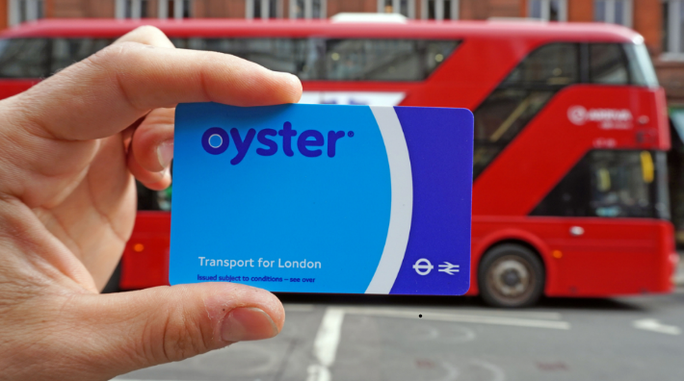

Figure ‎2‑1 Shows The Oyster Card

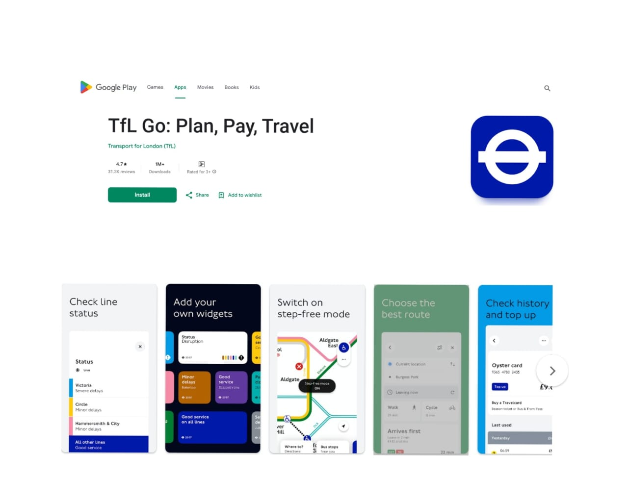

Figure ‎2‑2 Show Availability Android App on Play Store

TFL GO have guided UI to improve UX, it guides new users to get started as shown in Figure ‎2‑3

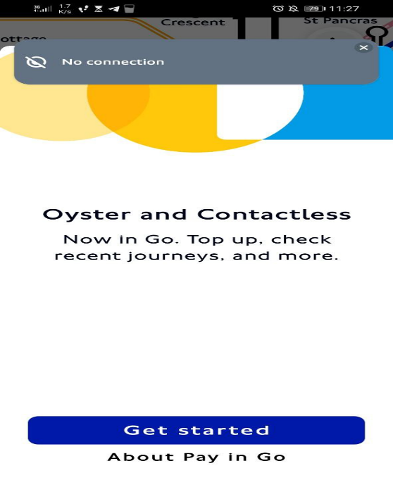

Figure ‎2‑3 Shows Guidance To Get Started

It also has management UI that contain account, setting for controlling saving history and sharing data, and tutorials, feedbacks, support in About as shown in Figure ‎2‑4

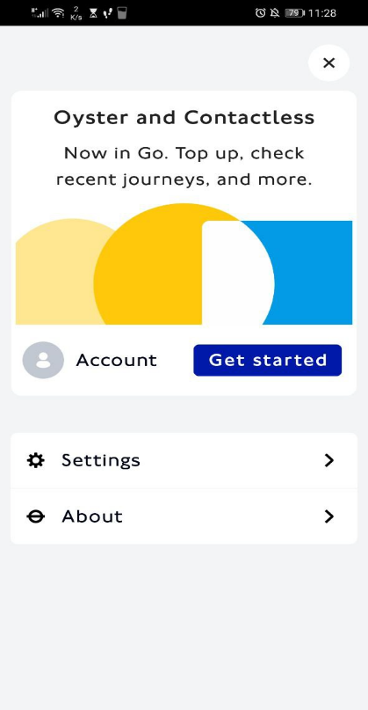

Figure ‎2‑4 Shows Management UI

The TFL application features a fixed map of London as its main interface, providing users with an interactive overview of the city’s transport network. The app includes several key functions accessible through dedicated buttons: Direction offers step-by-step route planning for the Tube, buses, and walking routes. Buses provides real-time arrival updates, route maps, and schedule information to help travelers navigate the bus network efficiently. Status alerts users to live service disruptions, delays, or closures across all TFL services, ensuring they can adjust their journeys as needed. Payment integrates contactless fare systems, Oyster card top-ups, and fare calculators for seamless transactions. Finally, GPS Location tracks the user’s position in real time, suggesting nearby stations, stops, and optimal routes based on their current whereabouts. Together, these features create a comprehensive tool for navigating London’s transport system with ease. As shown in Figure ‎2‑5

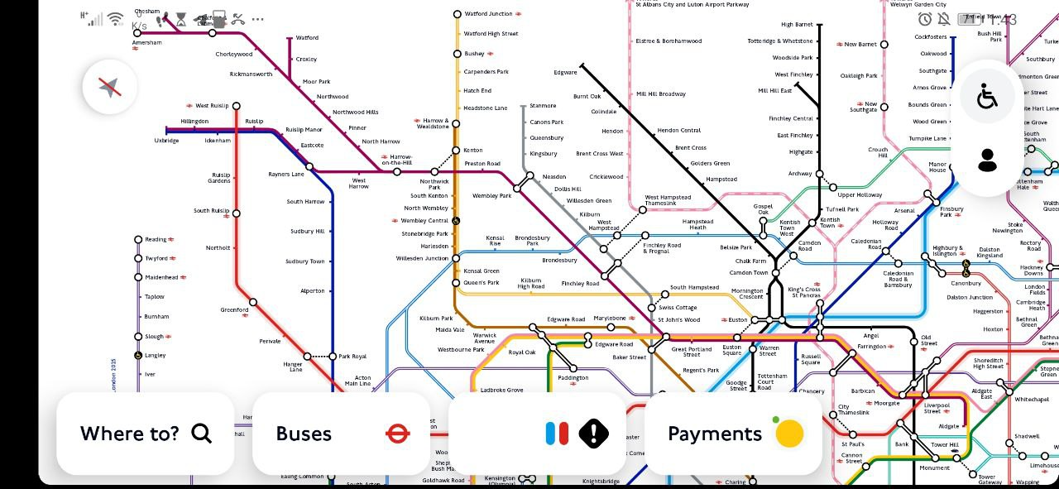

Figure ‎2‑5 Shows Interactive Map For Passengers To Control And View Trips

## Üstra Hannoversche Verkehrsbetriebe AG

Üstra Hannoversche Verkehrsbetriebe AG is the operator of public transport in the city of Hanover, Germany. The company is a member of the Großraum-Verkehr Hannover transport association. From 2003 to 2006, it had outsourced its operations, but officially resumed as a service provider on January 1, 2007 [2].

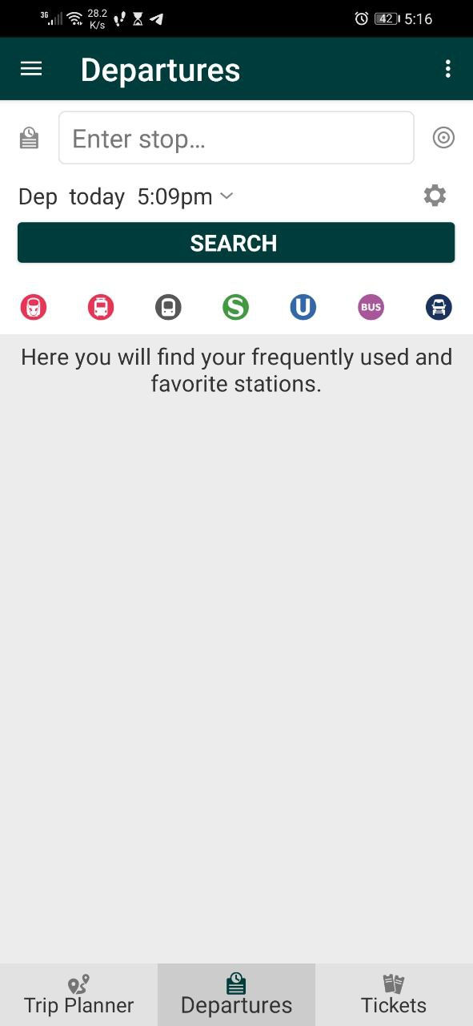Üstra does not support smart payment it relies on banking system, but it supports transportation help like seeing information about current trips. In addition, it is wider than traveling via bus yet it can include several transportation ways like train. As shown in Figure ‎2‑6

Figure ‎2‑6 Shows Optional Stop and the Wide Transportation Ways [7]

Moreover, it supports booking a ticket. as shown in Figure ‎2‑7

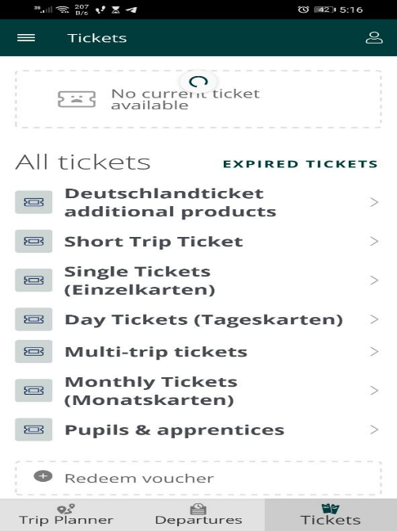

Figure ‎2‑7 Booking A Ticket [8]

Furthermore, it supports cross-platform like ios, android, and web apps. The app can search for near transport after indicating start-end trip as shown in Figure ‎2‑8

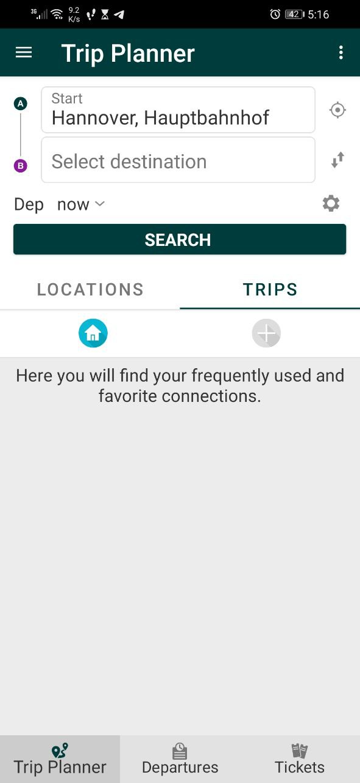

It offer several features shown in Figure ‎2‑9 , yet some features doesn’t work like news. Also booking tickets is disabled as shown in Figure ‎2‑7. It benefits from google map, and poor setting activity while it provides tutorials in information part.

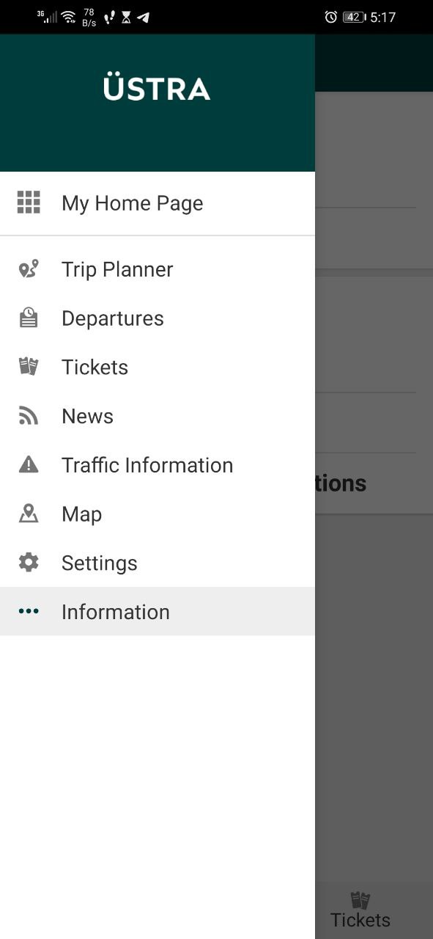

Figure ‎2‑8 Offer Several Features [10]

## SMART

SMART is serving since 1967, SMART is Southeast Michigan’s only regional public transportation provider, offering convenient, reliable and safe transportation for Macomb, Oakland and Wayne Countries. SMART’s Fixed-Route and small bus services connect people to employment and educational institutions**.** SMARTis supported by federal and state funding, local contributions through a transit property tax millage from opt-in communities and bus fares

SMART have web application that let customers to select start-end locations Figure ‎2‑10. Also it contains bus tracker to see the location of the bus on map in real-time. Moreover, it contains schedule for buses according to lines and streets. And it offer page for plan and prices Figure ‎2‑11. Furthermore, it offers news about the company and updates of the application Figure ‎2‑12.

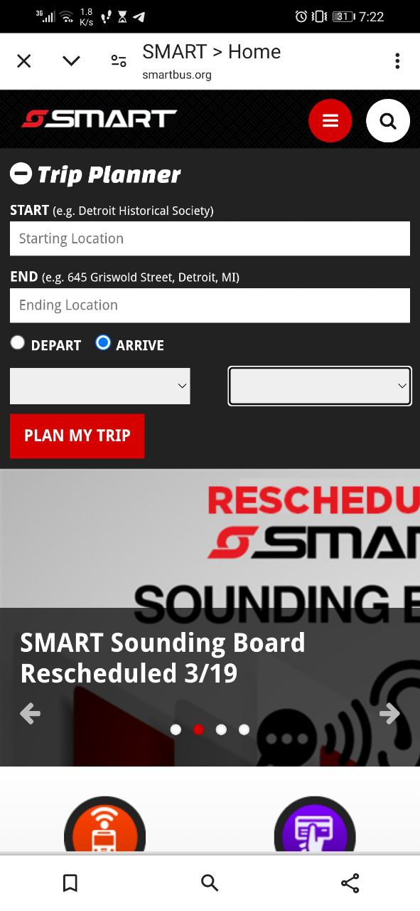

Figure ‎2‑9 Form Indicating Start-End Location Of Trip

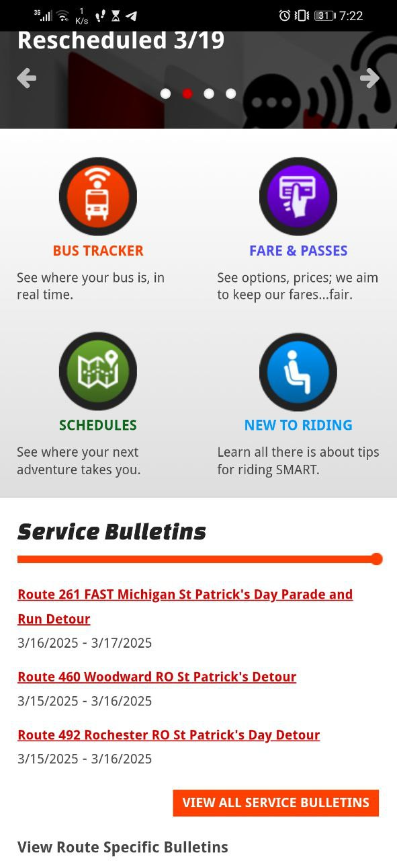

Figure ‎2‑10 Offers Tracking Plans Schedules And Tutorials

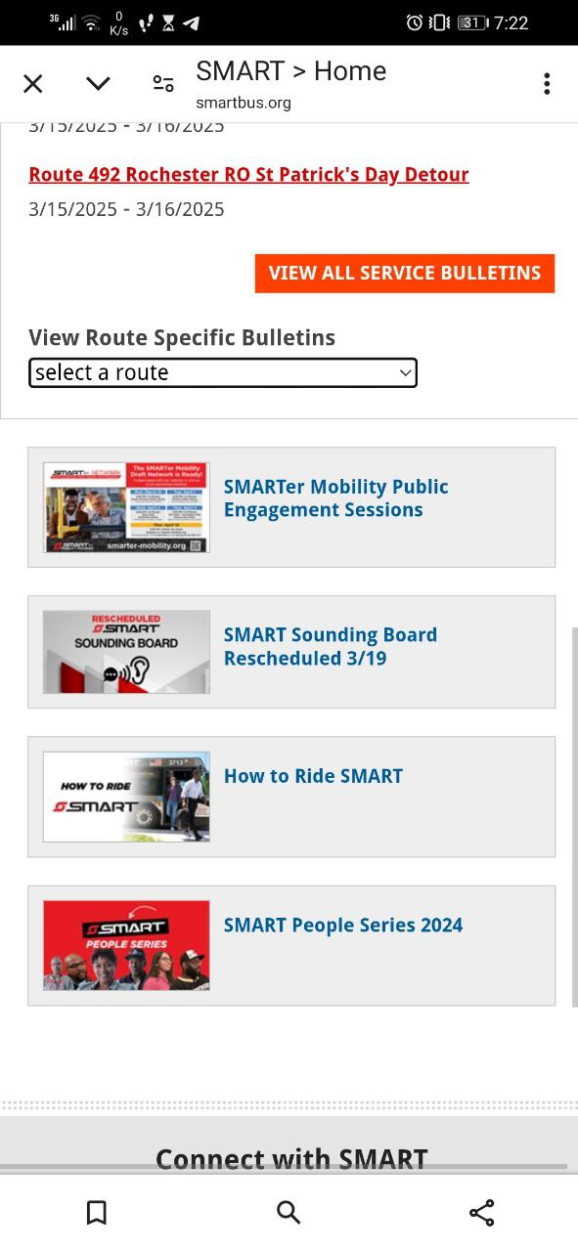

Figure ‎2‑11 Offers News About The Company And Updates

## Methods/Systems Comparison

This paragraph in meant to highlight the advantages and shortcomings of each of the previously stated methods with respect to certain criteria. Where Table 1 compare systems based on graphical user interface , and Table 2 compare systems according to content and functionality. In addition, Table 3 compare systems based on features .

Table 1 Comparison Table Based on Graphical Interfaces

|  |  |  |  |
| --- | --- | --- | --- |
| **Criterion 1** | **System 1** | **System 2** | **System 3** |
| **Graphical Interface** |
| Good user interface | ✓ | x | ✓ |
| Easy and effective navigation | ✓ | ✓ | ✓ |
| Simple and professional Design | ✓ | x | ✓ |
| Responsive | ✓ | ✓ | ✓ |

Table 2 Comparison Table Based on Content and Functionality

|  |  |  |  |
| --- | --- | --- | --- |
| **Criterion 2** | **System 1** | **System 2** | **System 3** |
| **Content and Functionality** |
| Quality content structure | ✓ | x | ✓ |
| Usability | ✓ | ✓ | ✓ |
| Dynamic content | ✓ | x | ✓ |
| Content management system | ✓ | x | ✓ |

Table 3 Comparison Table Based on Features

|  |  |  |  |
| --- | --- | --- | --- |
| **Criterion 3** | **System 1** | **System 2** | **System 3** |
| **Features** |
| Security measures | ✓ | ✓ | ✓ |
| Third party integration | x | ✓ | ✓ |
| Accessible content and location | ✓ | x | ✓ |
| Registration form | ✓ | ✓ | x |

## Conclusion and Motivation

As a conclusion the previous systems and methods show a variety of applications for same idea. All have transportation management. Some are on cross-platform like TFL and Uster while SMART is on single platform. Moreover, some contain smart payment via application while others are not. Based on these features this project will bypass some applications by improving features manage transportation, cashless and smart payment, and history of payments (transactions). This project will use web and android platforms web for admin while android for customer and bus scanner. In addition, we will use NFC technology that goes beyond software. Furthermore, this project will let customer be comfortable with software while making payments and recharging his account.

# System Design

## Introduction

This chapter explains the design of the Bus Management System, which uses real-time tracking and mobile payments to improve public transportation. We will cover the system's structure, how it works, and the tools used to build it. Diagrams will show the interactions between users and the system, as well as the data flow. We will also discuss costs, risks, and other practical considerations. By the end, you will understand how the system is planned and why these choices were made. This prepares the way for the next step: building and testing the system.

## Requirements and Specification Analysis

This section defines the system's core operational needs and technical specifications, ensuring all components work together effectively. The following subsections detail these requirements through structured documentation.

### Functional Requirements

The system must support:

* User Authentication
  + Valid email/phone registration
  + Secure password policies
* Hardware Dependencies
  + NFC support (bus terminals)
  + GPS (real-time tracking)
  + Camera (QR scanning)
* Connectivity
  + Constant internet connection (Firestore sync)
  + Mobile data/WiFi for all transactions
* Platform Requirements
  + Android OS for mobile apps
  + Web access for admin dashboard
* Core Feature
  + Real-time bus tracking (Google Maps/Leaflet)
  + QR/NFC fare payments
  + Transaction history storage
* Performance
  + <2s payment processing
  + <5s location updates

This structured approach ensures reliable operation across all system components.

### Use Case Diagrams

A UML use cases diagram is the primary form of system/software requirements for a new software program underdeveloped. Use cases specify the expected behavior (what), and not the exact method of making it happen (how). Use cases once specified can be denoted both textual and visual representation (i.e. use case diagram). A key concept of use case modeling is that it helps us design a system from the end user's perspective. It is an effective technique for communicating system behavior in the user's terms by specifying all externally visible system behavior [4].

* Figure ‎3‑1, presents the requirements of the Bus Management System through a structured use case diagram, categorizing features by user type. The system architecture centers on two key actors:

1. Passengers interact with:
   * Authentication services (Login/registration)
   * Digital payment interfaces (NFC tapping and QR code generation/scanning)
   * Real-time tracking tools (bus location monitoring, arrival time prediction, and station selection)
   * Account management (balance recharge, transaction history viewing, and personal information updates)
2. Administrators control:
   * User management (CRUD operations for system accounts)
   * Operational oversight (payment report analysis and bus fleet management)

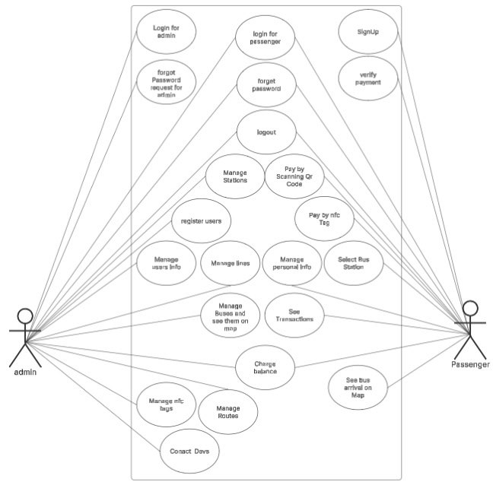

Figure ‎3‑1 Use case Diagram of System Project Highlighting

## System Architecture

This architecture outlines a real-time bus management system comprising three core components: an Admin Web Portal for managing user accounts, bus routes, and NFC card assignments; a Bus Application integrating an Arduino Uno with RC522 scanner to manually collect NFC tag UIDs during bus boarding; and a Passenger Mobile App for balance management and journey tracking - all synchronized through Firebase services (Authentication, Firestore for user/bus/NFC data, and Realtime Database for live locations). The system features a semi-automated workflow where bus conductors manually scan passenger NFC tags via Arduino, with UIDs subsequently uploaded to Firebase for payment processing and ridership tracking, while administrators monitor the entire fleet and manage NFC card allocations through the web interface, creating a hybrid digital-physical transit ecosystem.

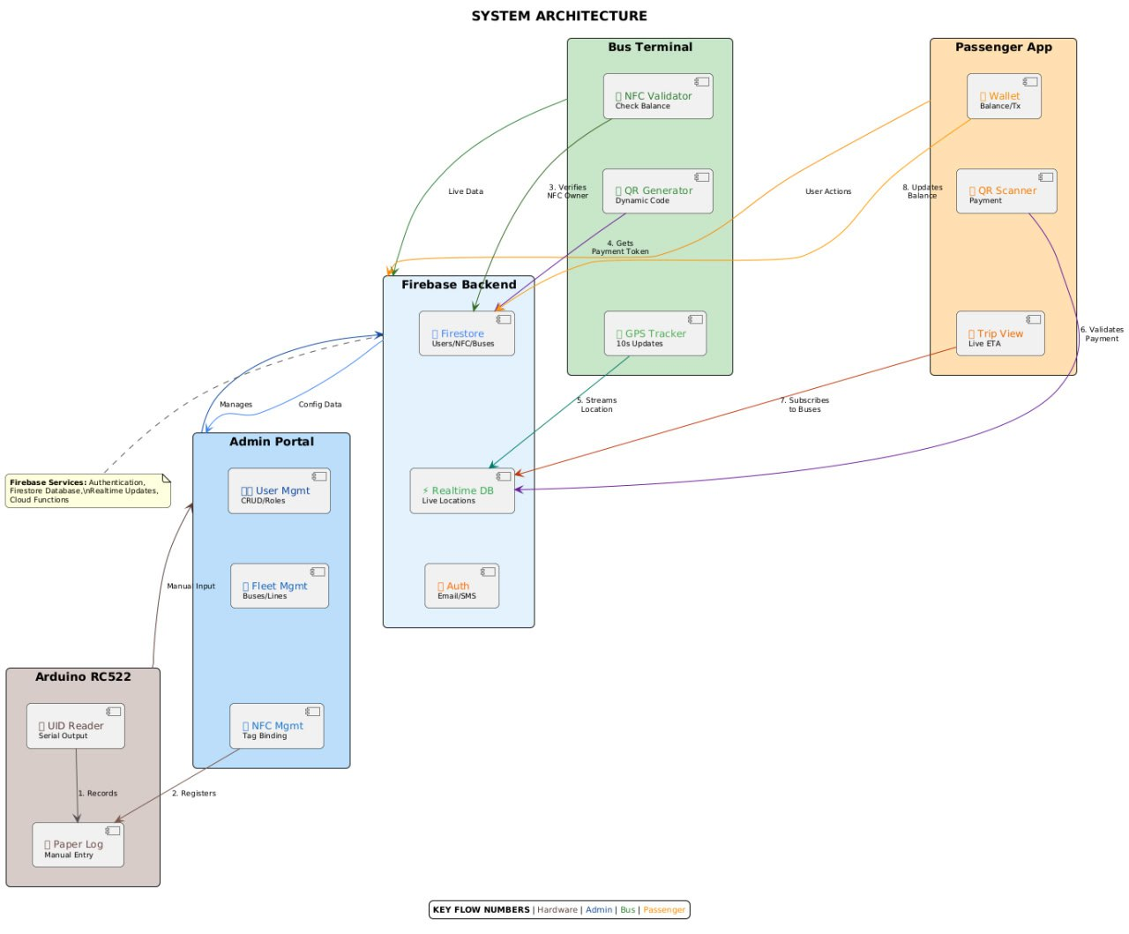

Figure ‎3‑2 System Architecture Diagram for The Bus Management Project

## Class Diagrams

Scanner Bus App:

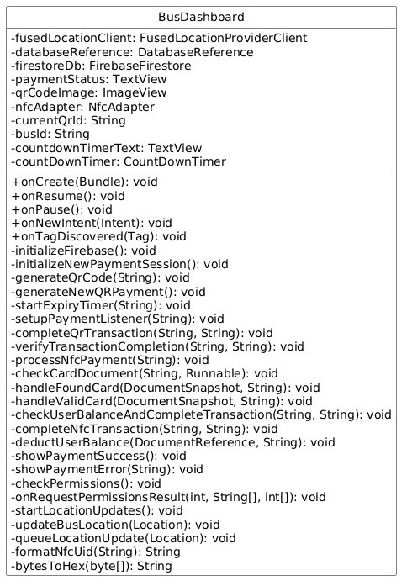

Figure ‎3‑3 Class Diagram For Main Activity in Bus App

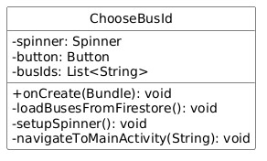

Figure ‎3‑4 Class Diagram For ChooseBusId in Bus App

Arduino Scanner:

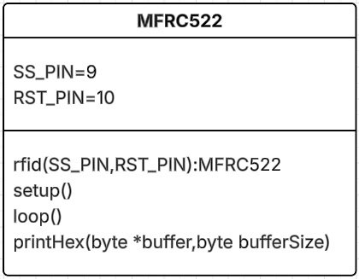

Figure ‎3‑5 Class Diagram For MFRC522 NFC Scanner

Passenger App:

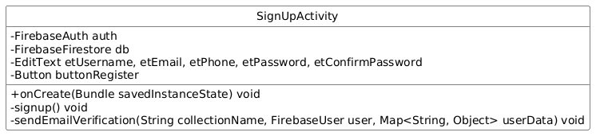

Figure ‎3‑6 Class Diagram for SignUpActivity of Passenger App

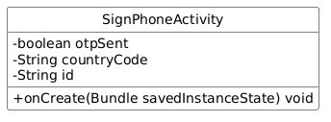

Figure ‎3‑7 Class Diagram for SignPhoneActivity of Passenger App

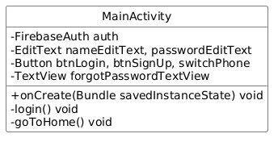

Figure ‎3‑8 Class Diagram for MainActivity of Passenger App

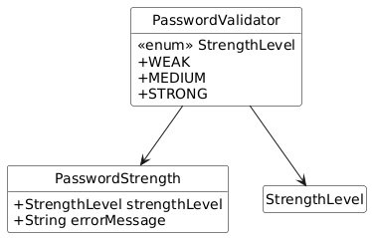

Figure ‎3‑9 Class Diagram for PasswordValidatorActivity of Passenger App

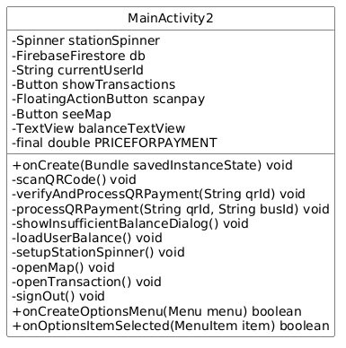

Figure ‎3‑10 Class Diagram for MainActivity2 of Passenger App

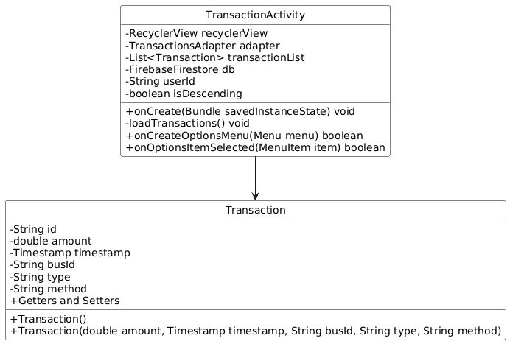

Figure ‎3‑11 Class Diagram for TransactionActivity of Passenger App

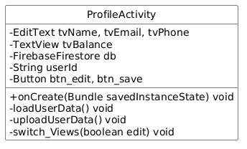

Figure ‎3‑12 Class Diagram for ProfileActivity of Passenger App

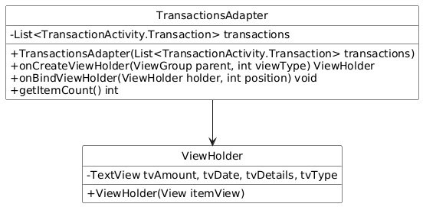

Figure ‎3‑13 Class Diagram for TransactionsAdapterActivity of Passenger App

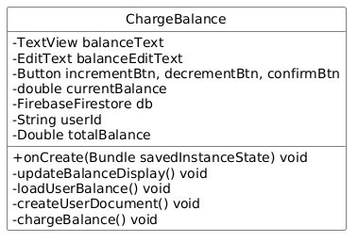

Figure ‎3‑14 Class Diagram for ChargeBalanceActivity of Passenger App

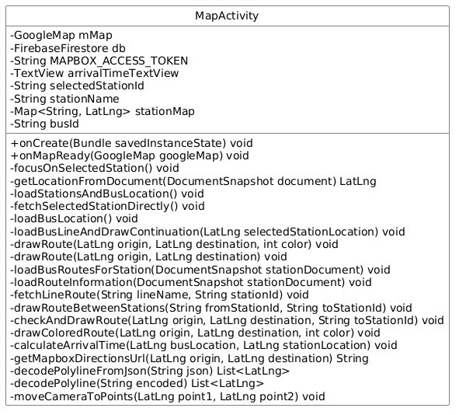

Figure ‎3‑15 Class Diagram for MapActivity of Passenger App

Admin Web App:

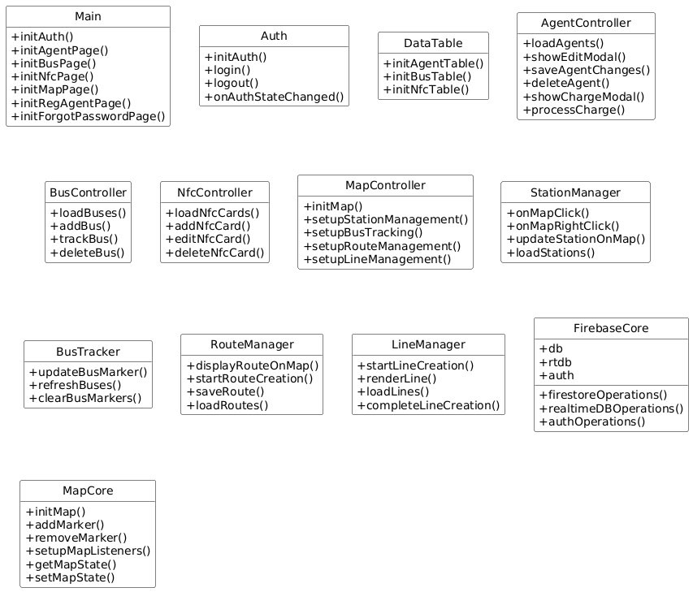

Figure ‎3‑16 Classes Diagrams for Web App

## Sequence Diagrams

The sequence diagram illustrates the key interactions between the bus payment app, Firebase services, and external components like NFC cards and passenger devices. It captures the main workflows, including QR code generation and validation, NFC payment processing, and real-time location updates. The diagram highlights how the app communicates with Firestore for transaction management and Realtime Database for GPS tracking, ensuring seamless coordination between the bus driver's interface, backend services, and passenger interactions.

Bus Scanner App:

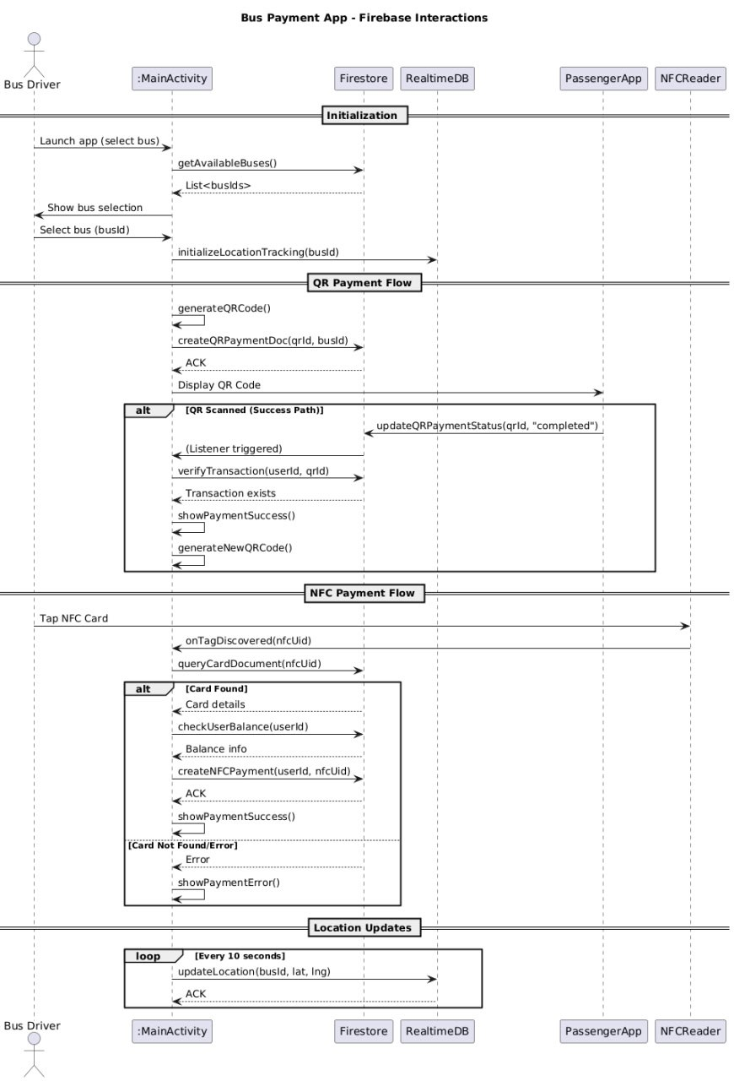

Figure ‎3‑17 Sequence Diagram for Bus Scanner App

Passenger Android App:

This sequence diagram outlines the end-to-end interactions within a Passenger Application, covering authentication flows (email, phone, registration, and password recovery) and core functionalities like QR payments, balance management, and map navigation. The system leverages Firebase services (Auth, Firestore, Database) for user management, real-time updates, and transaction processing, while integrating third-party APIs (Mapbox, Google Maps) for navigation. Each flow highlights the collaboration between UI components, backend services, and validation logic to deliver a seamless passenger experience.

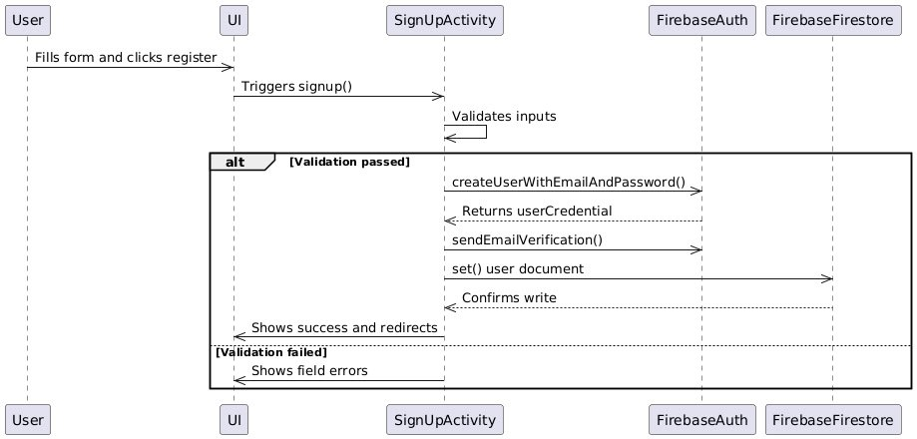

Figure ‎3‑18 Sequence Diagram of SignUpActivity from Passenger App

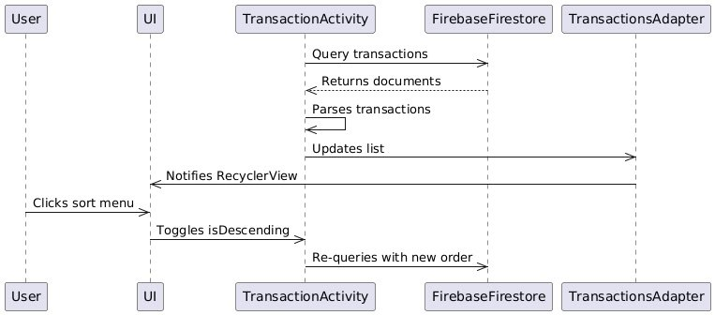

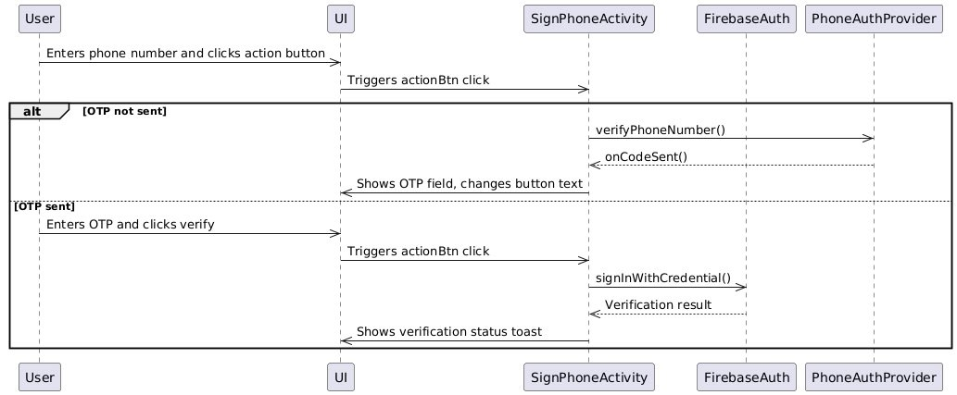

Figure ‎3‑19 Sequence Diagram of SignPhoneActivity from Passenger App

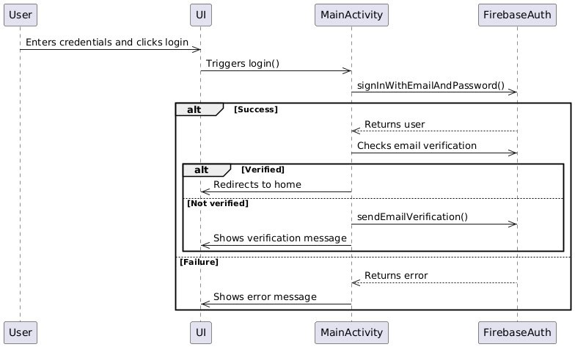

Figure ‎3‑20 Sequence Diagram of MainActivity from Passenger App

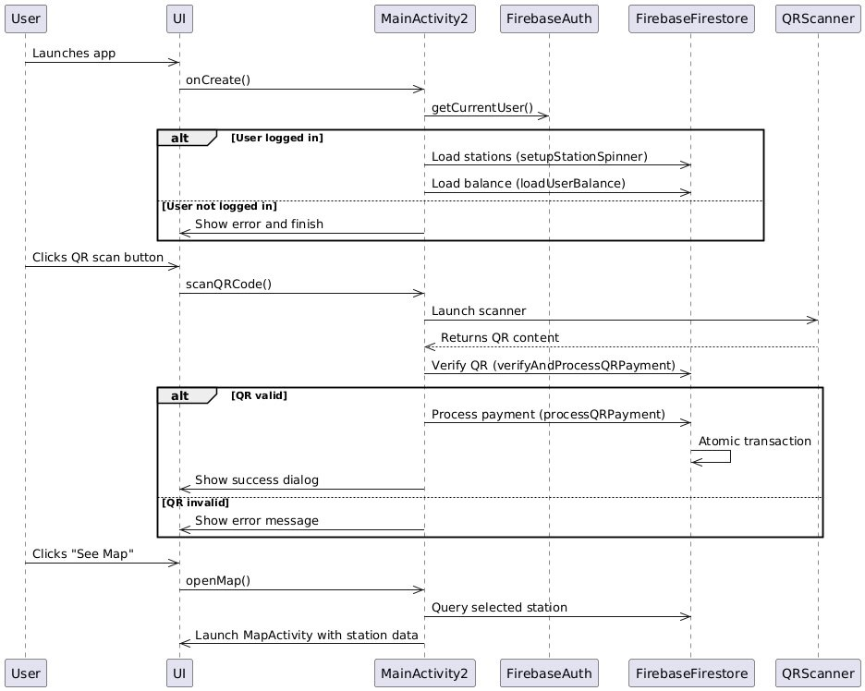

Figure ‎3‑21 Sequence Diagram of MainActivity2 from Passenger App

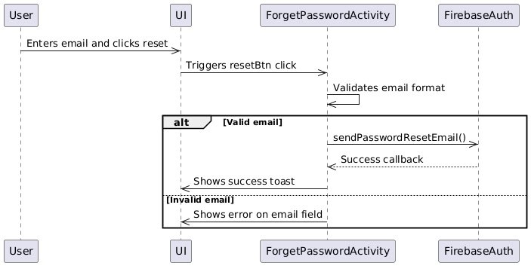

Figure ‎3‑22 Sequence Diagram of ForgetPasswordActivity from Passeneger App

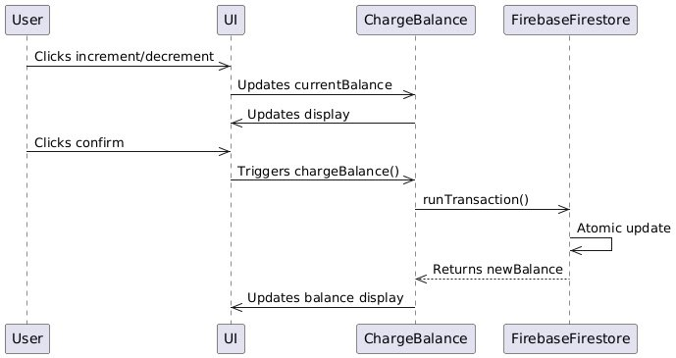

Figure ‎3‑23 Sequence Diagram of ChargeBalanceActivity from Passeneger App

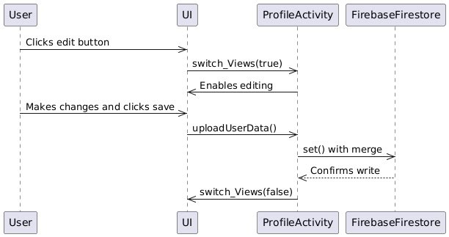

Figure ‎3‑24 Sequence Diagram of ProfileActivity from Passeneger App

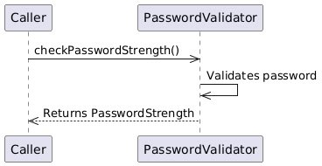

Figure ‎3‑25 Sequence Diagram of PasswordActivity from Passeneger App

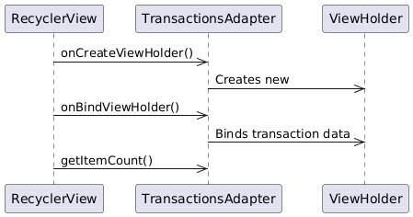

Figure ‎3‑26 Sequence Diagram of TransactionsAdapterActivity from Passeneger App



Figure ‎3‑27 Sequence Diagram of TransactionsActivity from Passeneger App

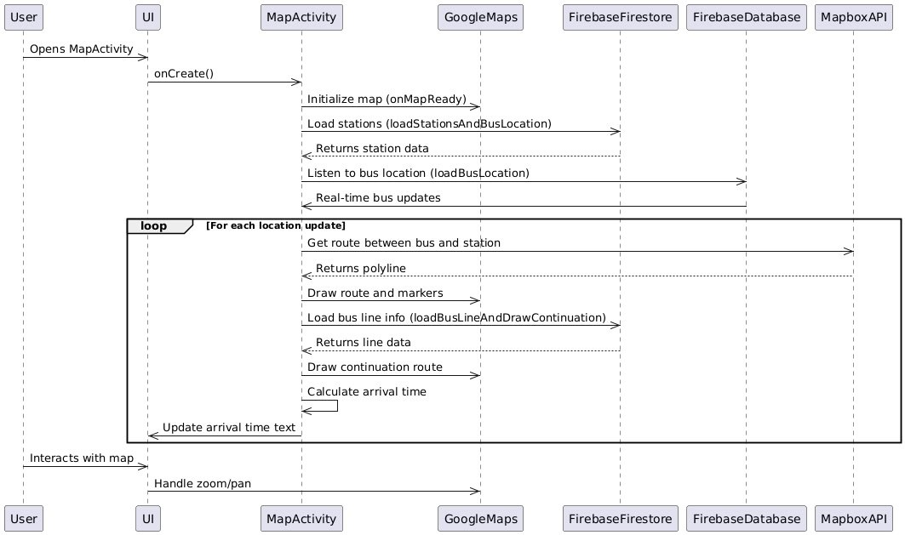

Figure ‎3‑28 Sequence Diagram of MapActivity from Passeneger App

Admin Web App:

The SmartBus client-side sequence diagram illustrates the interactions between a user and various frontend components of a web-based transportation management system. It begins with user authentication using Firebase Auth and Firestore, supporting both user and agent-based logins. Post-authentication, users can navigate dashboards for managing buses, stations, routes, lines, NFC cards, and viewing maps. The application integrates real-time updates from Firebase Realtime Database to track bus locations dynamically, while Firestore handles structured data like routes and user details. UI components and map-based interactions allow for intuitive station placement, route and line creation, and NFC management, ensuring a seamless and responsive user experience.

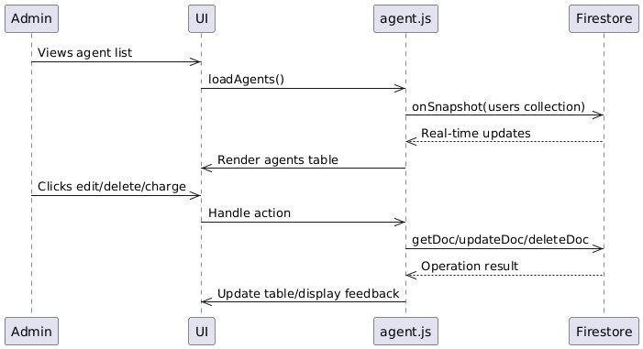

Figure ‎3‑29 Sequence Diagram for agent.js in Admin Web App

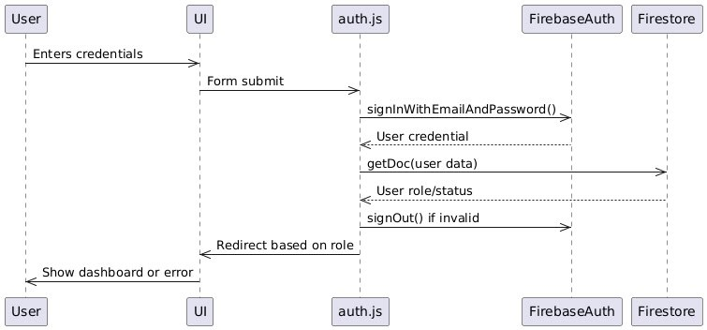

Figure ‎3‑30 Sequence Diagram for auth.js in Web App

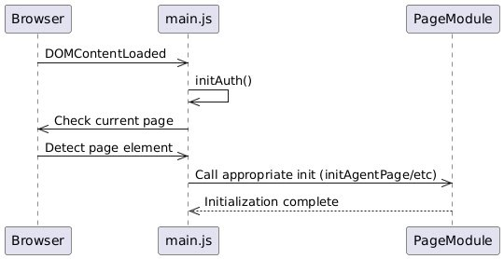

Figure ‎3‑31 Sequence Diagram for main.js in Web App

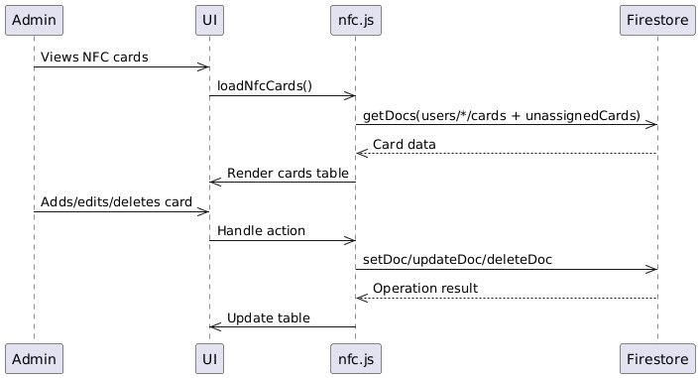

Figure ‎3‑32 Sequence Diagram for nfc.js in Web App

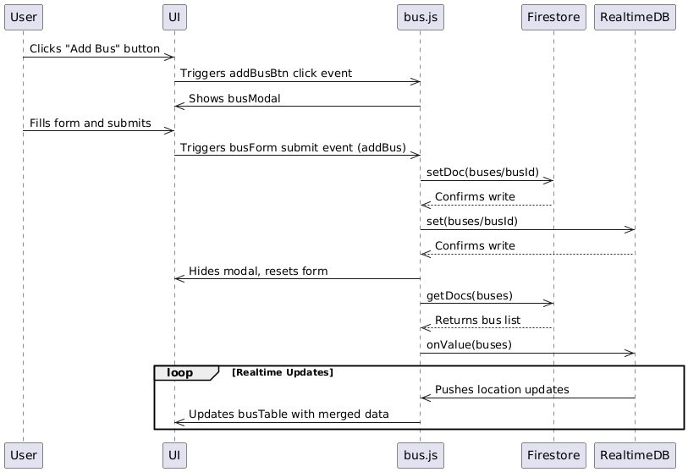

Figure ‎3‑33 Sequence Diagram for bus.js in Web App

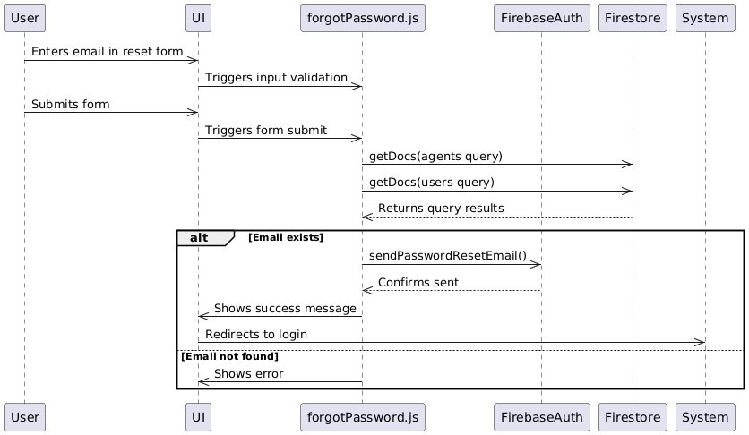

Figure ‎3‑34 Sequence Diagram for forgotPassword.js in Web App

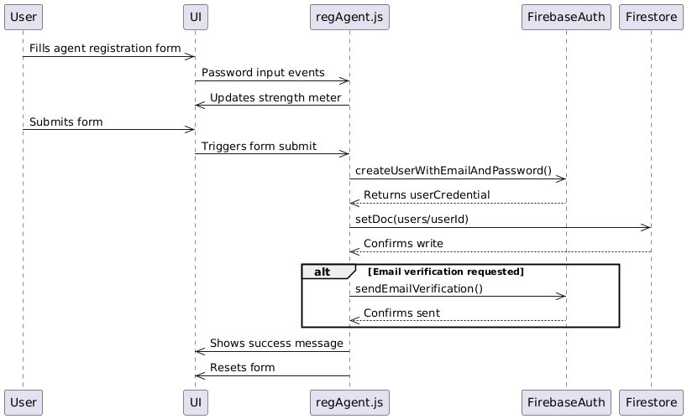

Figure ‎3‑35 Sequence Diagram for regAgent.js in Web App

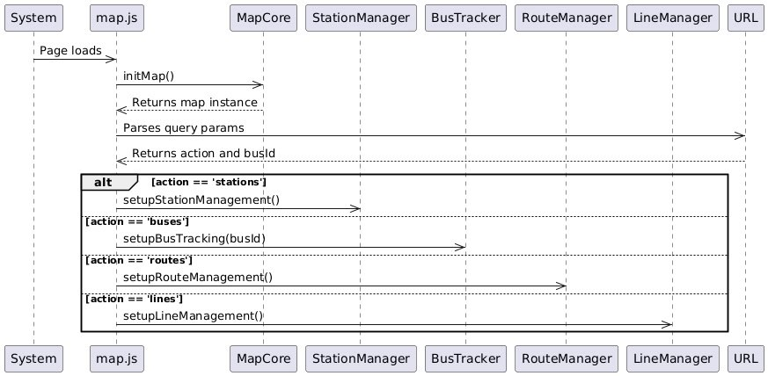

Figure ‎3‑36 Sequence Diagram for map.js in Web App

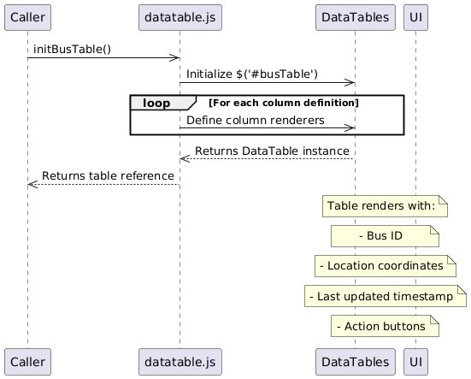

Figure ‎3‑37 Sequence Diagram for datable.js in Web App

## Activity Diagrams

Admin Web App Activity

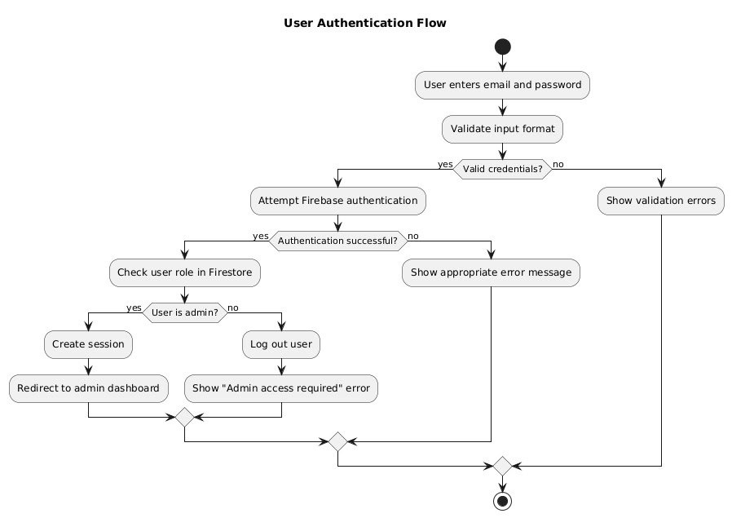

Figure ‎3‑38 Activity Diagram of initAuth() function from auth.js of Web App

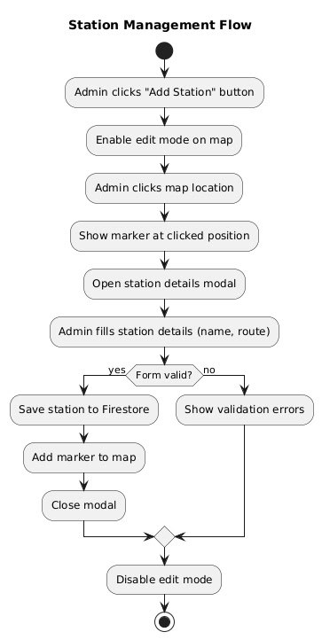

Figure ‎3‑39 Activity Diagram for setupStationManagement() function from station-manager.js from Web app

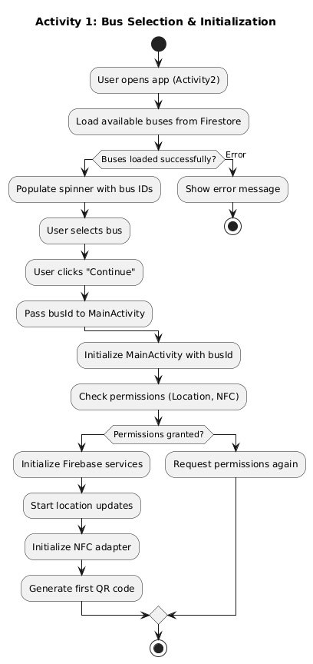Bus Scanner App:

Figure ‎3‑40 Activity Diagram for Initializing BusId for App in Bus Scanner App

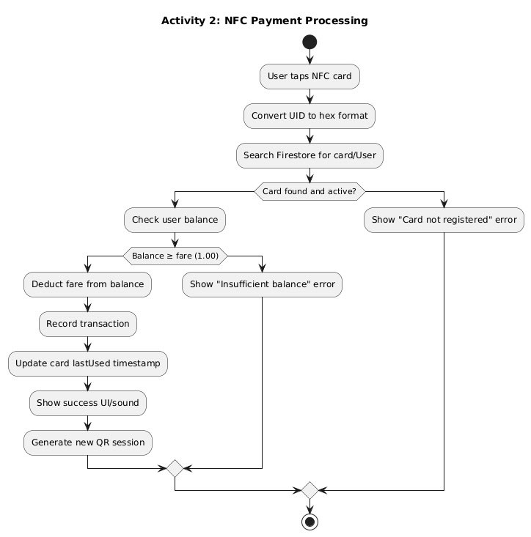

Figure ‎3‑41 Activity Diagram for NFC payment Processing

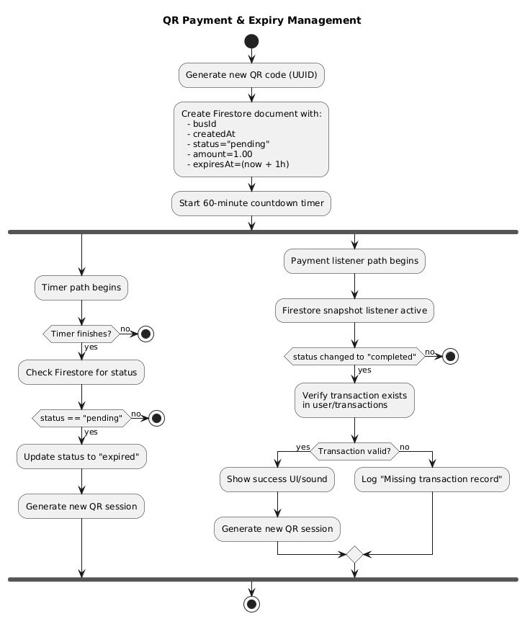

Figure ‎3‑42 Activity Diagram for Qr Payment and Expiry Management in Bus Scanner App

## Entity-Relationship (ER) Diagrams

In this project we will use firebase fire-store that is nosql database. And data is organized as documents in collection and sub-collections.

Collection: A group of documents within a database, similar to a table in relational databases. Document: A single data record within a collection, stored as a BSON object [5].

## Non-Technical Aspects

### Financial Viability

This table shown below Table 4 shows costs of tools in our project

Table 4 Caption Cost Benefit Table

|  |  |
| --- | --- |
| **Benefits** | **Costs** |
| NFC card per passenger | 5$ |
| Android Mobile Phone per bus | 275$ |
| Charging Internet 6GB Alfa Bundles | 9.61$ |
| Website Hosting | 5-90$ |
| **Total** | **$119.61-204.61** |

### Stakeholders

People that will Benefit:

• Passengers enjoy faster boarding, cashless convenience, and real-time bus tracking.

• Transport Operators gain better revenue control, reduced fraud, and efficient fleet management.

• City Authorities benefit from data-driven urban planning and reduced traffic congestion.

Potentially Affected Parties:

• Cash-dependent users (e.g., unbanked populations) may face exclusion unless alternative payment options (e.g., prepaid NFC cards) are provided.

• Traditional ticket vendors could lose income if phased out.

Decision-Makers:

Transport agencies, municipal governments, and software maintainers should collaborate on system policies, pricing, and accessibility measures.

### Scope

What will be done in the project:

• Real-time GPS tracking of buses via Firebase.

• NFC/QR-based fare collection for agents.

• Admin web portal for agent management, station editing, and live map monitoring.

• Agent mobile app for balance checks, payments, and bus arrival predictions.

• Agent self-recharge (bank-linked) or admin-assisted.

what will not be done in the project:

• External bank NFC cards (project issues its own cards).

• Offline payment modes (requires mobile data).

• Android/web apps (no iOS/Flutter).

• NFC/QR payments only for buses (no other transport).

### Risks

Things that may stop the project from achieving the goals in the scope are:

• Technical Failures: GPS signal loss or Firebase downtime could disrupt tracking.

• Security Threats: Unauthorized access to payment data or GPS spoofing.

• Budget Overruns: Hardware costs (e.g., NFC scanners) may exceed estimates.

• Network Dependency: Mobile data outages halt payments/tracking.

• NFC Hacking: Tools like Flipper Zero could clone cards (mitigation: encryption).

• Agent Fraud: Fake QR codes or balance tampering.

### Schedule and Milestones

Table 5 shows a structured breakdown of the project's key tasks, organized in a logical sequence from initial planning to final testing and debugging. Each task is assigned an ID for easy reference, along with designated start and finish points to track progress. The table also includes a duration column, indicating the estimated time required for each phase. The workflow follows a systematic approach, beginning with research and requirement identification, progressing through design and development, and concluding with integration and testing.

Table 5 Project Development Timeline: From Planning to Completion

|  |  |  |  |  |
| --- | --- | --- | --- | --- |
| Task | ID | Start | Finish | Duration |
| Project Brief & Initial Planning | 1 | 22/2/2025 | 28/2/25 | 6 Days |
| Research on Similar Systems | 2 | 25/2/2025 | 27/2/25 | 3 Days |
| Literature Review | 3 | 28/2/2025 | 5/3/2025 | 6 Days |
| Identifying System Requirements | 4 | 6/3/2025 | 10/3/2025 | 5 Days |
| System Design & Prototyping | 5 | 11/3/2025 | In Progress |  |
| Development of Android App Dashboard | 6 | 14/3/2025 | In Progress |  |
| Development of Web Dashboard | 7 | 14/3/2025 | In Progress |  |
| Hardware & Integration | 8 | - | - | - |
| Testing and Debugging | 9 | - | - | - |

### Ethical and Social Considerations

* Security: NFC encryption to deter hacking.
* Accessibility: Mobile data costs may burden operators in low-coverage areas.
* Inclusivity: Ensures unbanked users can access prepaid NFC cards.
* Privacy: Anonymize GPS/payment data to protect user identities.
* Transparency: Clear pricing and transaction records for agents.

### Environmental and Sustainability Considerations

The project has minimal environmental impact. Digital payments reduce paper ticket waste, while optimized routes may lower fuel consumption. Future iterations could incorporate electric bus compatibility.

### Relevant Standards

* Payment Security: ISO/IEC 14443 (NFC standards), PCI DSS (QR code transactions).
* Accessibility: WCAG 2.1 (for mobile/web app usability).
* Mobile Data: 4G/5G reliance (no WiFi).

## Conclusion

Chapter 3 has presented the comprehensive system design for the Bus Management System, detailing both its technical architecture and non-technical considerations. Through requirements analysis and specification, we established the functional needs of the system, supported by use case diagrams that illustrate user interactions. The system architecture was defined using a client-server model with Firebase backend, while class diagrams, sequence diagrams, and activity diagrams provided visual representations of the system's structure and workflows. The Entity-Relationship diagram further clarified the data model supporting the application.

The non-technical aspects section addressed critical implementation factors including financial viability, stakeholder impacts, and project scope limitations. Key risks were identified, particularly around network dependency and security vulnerabilities, along with mitigation strategies. The project schedule outlined an achievable development timeline, while ethical and environmental considerations ensured responsible system design. Relevant standards were documented to guarantee compliance with industry best practices.

This chapter successfully bridges the gap between conceptual planning and practical implementation, providing a robust foundation for the system's development. The design balances technical innovation with real-world constraints, ensuring the solution is both functional and sustainable. With these elements thoroughly addressed, the project is well-positioned to move into the development phase while maintaining alignment with its core objectives of improving bus transportation efficiency through digital transformation.

# Implementation/Simulation and Testing

## Introduction

This chapter details the practical execution of the Bus Management System, covering the tools used, implementation steps, testing procedures, and results. Section 4.2 lists and defines the tools employed in the project, explaining their roles in development. Section 4.3 outlines the implementation process, including key code fragments and system integration. Section 4.4 describes the test cases and acceptance criteria, along with the outcomes of feature testing. Finally, Section 4.5 concludes the chapter, summarizing achievements and noting any limitations or future improvements that could enhance the system.

## Implementation Tools

Below are the tools used in the project, along with their definitions and applications:

* Android Studio:
  + Definition: An integrated development environment (IDE) for Android app development.
  + Usage: Used to build the passenger and bus-side mobile apps, leveraging its emulator and Firebase integration.
* Firebase (Firestore, Realtime Database):
  + Definition: A NoSQL cloud database and backend service by Google.
  + Usage: Firestore stores {users, transactions, cards, buses, qrPayments, lines, stations} data; Realtime Database handles live bus GPS tracking. Moreover, it provide FirebaseAuth interface that provide various authentication methods.
* NFC Tags:
  + Definition: Passive devices storing data for contactless communication.
  + Usage: Embedded in cards for fare payments via the bus-side NFC scanner.
* Arduino Uno R3:
  + Definition: A microcontroller board for hardware prototyping.
  + Usage: Powers the NFC (RC522) scanner on buses to read tags and add the UID of tags readed to database manually.
* RC522 Module:
  + Definition; A low-cost NFC reader/writer module.
  + Usage: Integrated with Arduino to scan NFC cards to extract UID.
* Leaflet:
  + Definition: An open-source JavaScript library for interactive maps.
  + Usage: Renders real-time bus locations, and it displays stations, lines, and routes on map for admin web app.
* Google Map API:
  + Definition: A set of APIs that allow Android apps to display maps, track locations, and provide navigation features.
  + Usage: Integrated into the Passenger App to:
    - Display real-time locations of the bus on an interactive map.
    - Show estimated arrival time (ETAs) based on live GPS data.
    - Provide route visualization between selected station and bus arriving to it post station of the bus.
* PlantUML:
  + Definition: A tool for creating UML diagrams from text.
  + Usage: Generated system design diagrams (e.g., class, sequence, Activity diagrams)
* GitHub:
  + Definition: A platform for version control and collaborative coding.
  + Usage: Hosted source code and tracked project milestones. In addition, it provides backup cloud shared memory for our files.
* Lucidchart:
  + Definition: A web-based diagramming tool.
  + Usage: Designed use-case diagrams for system architecture
* VsCode;
  + Definition: A lightweight code editor with extensions.
  + Usage: Developed the admin web app using HTML/CSS/JavaScript.
* jQuery:
  + Definition: A JavaScript library simplifying DOM manipulation.
  + Usage: Enhanced interactivity in the tables of information in web app (e.g. buses,users,cards…).
* Awesome Font Library:
  + Definition: A collection of scalable vector icons.
  + Usage: Improved UI design in web apps, especially used in providing icons for the action buttons in data tables.

## Implementation Summary

Description of detailed implementation steps. Demonstrate the typical code fragments (details of implementation, e.g. source code listings must be included in an appendix and saved on an accompanying CD/DVD)

## 

## Test Cases and Acceptance Criteria

Describe the test cases used and the acceptance criteria.

## Conclusion

This paragraph in meant to draw conclusions highlighting the main ideas in this chapter.

# Conclusion and Future Work

## Conclusion

Any concluding remarks, lesson learned, etc…

## Future Work

Describe the opportunities for expanding the work done in this thesis.

**APPENDIX A:   
Implementation Details**

Any details not fit in chapter 5: e.g. detailed calculation, complex algorithms, etc…

**APPENDIXB:  
 USER Manual**

Fill in the instruction manual for using the application

**APPENDIXC:   
deployment and configuration Manual**

Outline the deployment and configuration details in addition to any know troubleshooting techniques.

**REFERENCES**

|  |  |
| --- | --- |
| [1] | "Transport for London," 5 3 2025. [Online]. Available: https://en.wikipedia.org/wiki/Transport_for_London. [Accessed 1 4 2025]. |
| [2] | W. Contributors, "üstra," 7 12 2024. [Online]. Available: https://en.wikipedia.org/wiki/%C3%9Cstra. [Accessed 1 4 2025]. |
|  |  |
| [4] | V. Paradigm, "What is Use Case Diagram?," 2019. [Online]. Available: https://www.visual-paradigm.com/guide/uml-unified-modeling-language/what-is-use-case-diagram/. [Accessed 31 4 2025]. |
| [5] | "MongoDB – Database, Collection, and Document," GeeksforGeeks, 5 2013. [Online]. Available: https://www.geeksforgeeks.org/mongodb-database-collection-and-document/. [Accessed 4 5 2025]. |
| [6] | J. P. Wodehouse and D. Dobrowsky, "The Economics of a Transport and or Delivery Business," 21 2 2023. [Online]. Available: https://extension.psu.edu/the-economics-of-a-transport-and-or-delivery-business. [Accessed 6 7 2023]. |
| [7] | [Online]. Available: https://play.google.com/store/apps/details?id=de.hafas.android.gvh&hl=ar. |
| [8] | [Online]. Available: https://play.google.com/store/apps/details?id=de.hafas.android.gvh&hl=ar. |
| [9] | [Online]. Available: https://play.google.com/store/apps/details?id=de.hafas.android.gvh&hl=ar. |
| [10] | [Online]. Available: https://play.google.com/store/apps/details?id=de.hafas.android.gvh&hl=ar. |